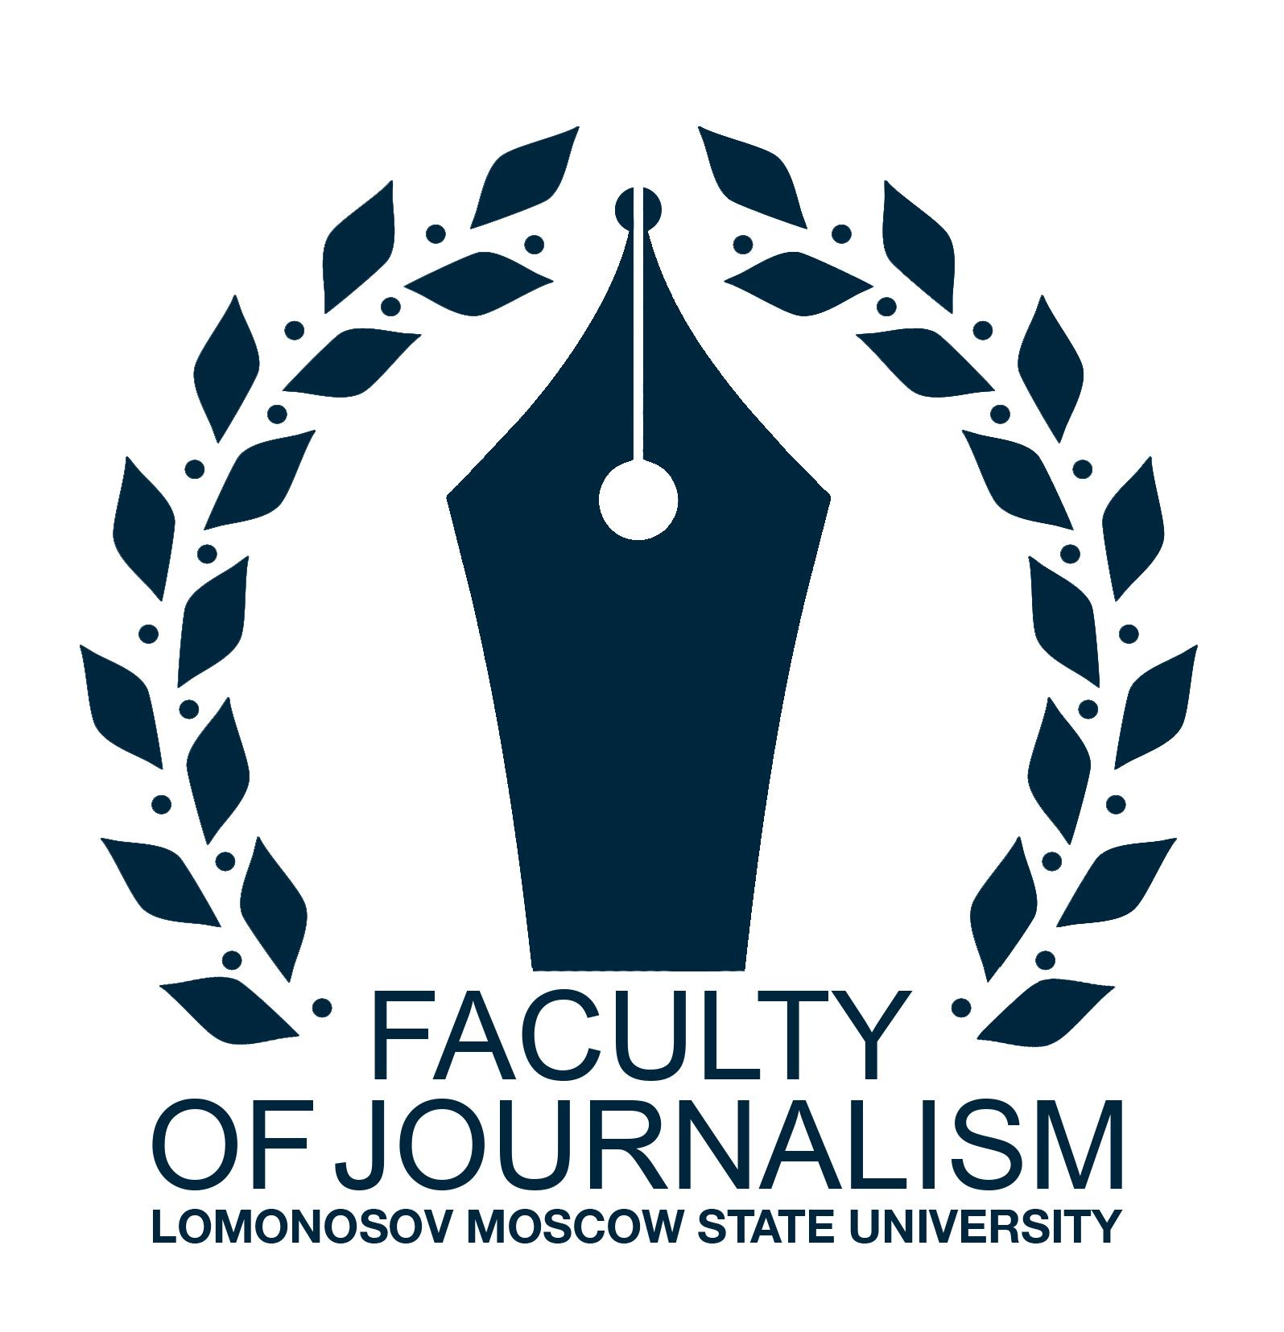
Факультет журналистики МГУ имени М.В. Ломоносова  Филологический факультет РУДН  Хартумский университет  20 октября 2022 г. Москва | Faculty of Journalism, Lomonosov Moscow State University  Faculty of Philology of RUDN University  University of Khartoum  October 20, 2022, Moscow

THE FIRST INTERNATIONAL HUMANITARIAN FORUM
Russian Culture in Modern World

The First International Humanitarian Form is a platform for discussing key issues related to global cultural interactions and sharing the best practices to build up sustainable relationship in humanitarian area between scholars around the globe.
The main goal the Forum is to focus on human potentials as a contribution to future development. The Forum is an opportunity to create a tool for the development of research and scientific dialogue based on the exchange of experience of Russian and foreign scholars in the humanities.
We invite:
- professors
- researchers
- PhD and master students
- students
Forum language: English, Russian.

Session 1. «Russian language and literature in intercultural communication»
Intercultural communication is one of the most important components of foreign language teaching methodology. The session will discuss modern level approaches to forming intercultural communication competence, parameters relevant to describing communicative behavior of Russians and foreigners, methodological interpretations of the results already obtained, which are reflected in the development of cross-cultural adapters in the process of preparing students for intercultural interaction. Participants will also discuss the history of Russian language, Russian literature, modern Russian language, and comparative analysis of linguistic features.
Topics for discussion:
- Language and literature as a means of communication between different cultures
- History and reception of the Russian language and literature in the world
- Intercultural communication in the practice of teaching the Russian language to foreign students
- Translation of Russian writers’ works
- Africa in the artistic world of Russian writers
- The image of Russia in the artistic world of writers from different countries
- Russian literature in the context of cultural dialogue
- Technologies of teaching the Russian language in the context of intercultural communication
- Russian teachers in foreign universities
- New perspectives of intercultural communication between Russia and the world

Session 2. Media and Journalism in Modern Digital Environment: Russian and African experience
This session is dedicated to the new challenges and opportunities that arise in mass communications because of the transformation of the modern digital environment. The convergence of formats and genres, the emergence of new ways of content production, the increasing influence of platforms, and the changing role of the audience in mass communication require detailed academic analysis, especially in the context of growing uncertainty in the media environment.
During this session we will discuss the impact of contemporary media trends on all spheres of our lives: social, economic, cultural, academic, etc. We appreciate empirical and theoretical works that explore contemporary journalism, journalism education, transformations in the media economy, and the effects of mass communication, focusing on the specific Russian and African experience. We will also discuss the increasing role of mediatization in modern society, the transition of many social processes into the media sphere, professional and ethical standards, and the place of non-institutionalized communicators in the modern public sphere.
Researchers who look at the phenomenon of journalism from a historical perspective are also invited to participate.

Topics for discussion:
- The role of new media in contemporary society
- Audience as a new type of mass communicator
- Traditional media in the digital era: factors of transformation
- Media economy and media management: organizational and monetization trends
- The language of mass media in the digital age
- History of journalism: tradition and continuity
Publishing opportunities
Best papers will be published in peer-reviewed book of articles (indexed in national online library eLIBRARY.RU)
Date of the conference: October 20, 2022
Deadline for submission: September 5, 2022
Registration fee
1500 rubles (1000 rubles for students) including the cost of publishing abstracts and certificate of participation
Foreign Participants – free of charge
Venue of the Conference: Russia, Moscow, St. Miklukho-Maklaya, 10, building 2 "A" (entrance through the building of the Faculty of Humanities and Social Sciences through 5-7 floors)
Contacts
Organizing committee: inthumfor.org@gmail.com
Abstracts for ‘Russian language and literature in intercultural communication’ session: rushumanscience2022@gmail.com
Abstracts for ‘Media and journalism in the modern digital environment: Russian and African experience’ session: mediaconf@mail.ru
Abstract guidelines
Please, send your abstracts (up to 4000 characters) in doc or .docx formats in English or Russian, including author(s) name(s) and affiliation(s)
Sincerely,
Forum Organizing Committee

